# Restore database for 1st use.

Goto: <http://localhost:8099/web/database/manager>

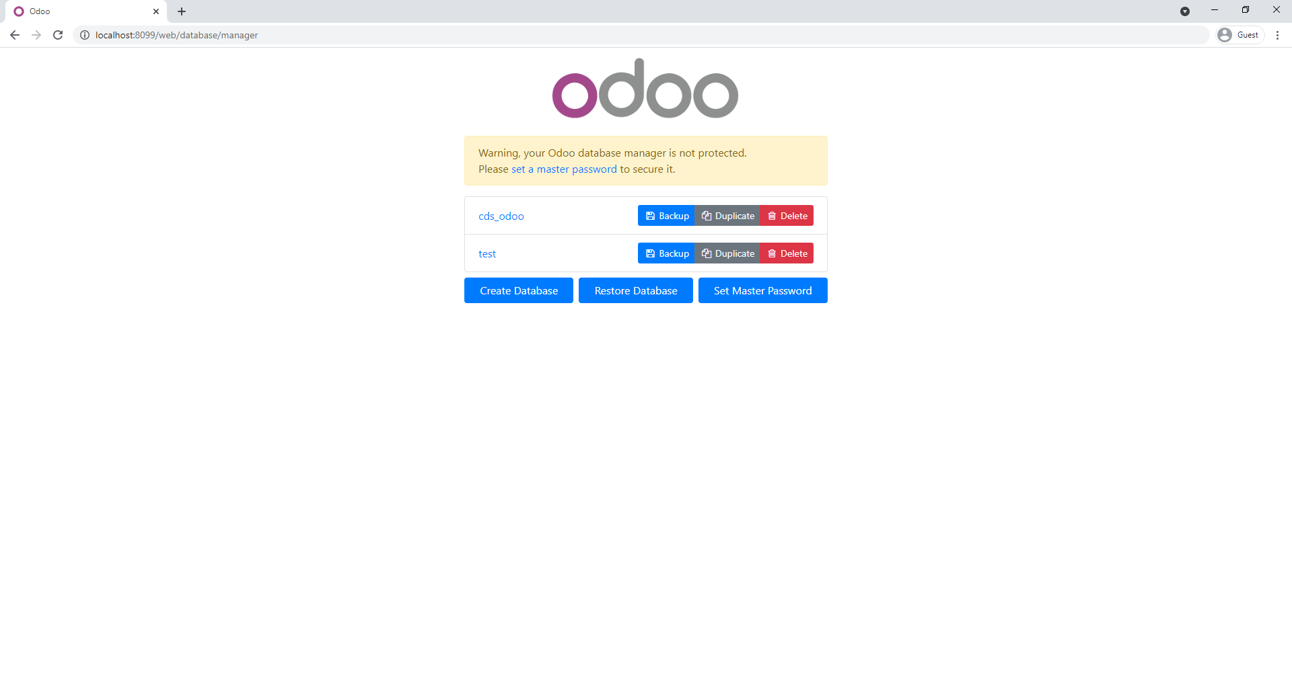

Click on Restore Database and choose backup zip file. Enter database name and Continue. It will took a bit longer.

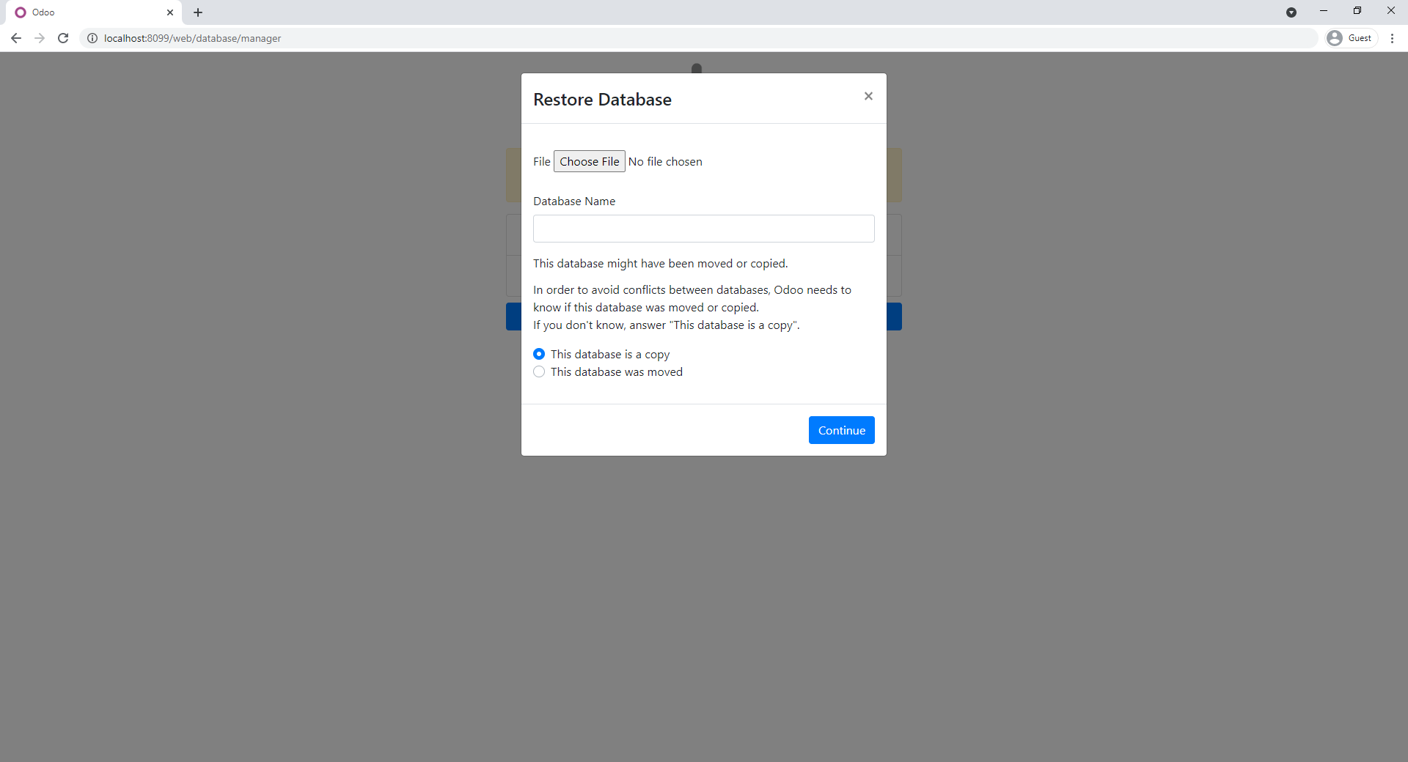

# Error key error because of missing column in database:

I ran in to key error payment_discount_in_invoicing in rec object

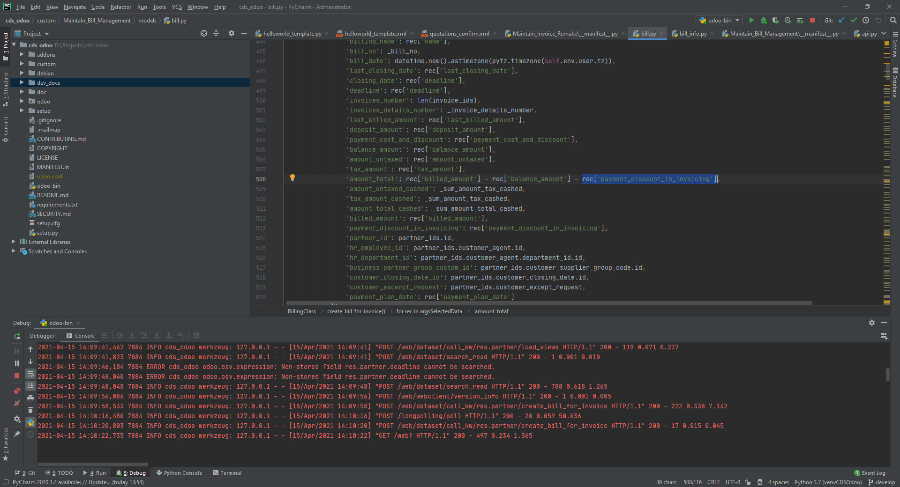

If we cover it with rec.get(‘payment_discount_in_invoicing’, 0), it will throw another error: missing column payment_discount_in_invoicing in bill.info table through there already payment_discount_in_invoicing in model.

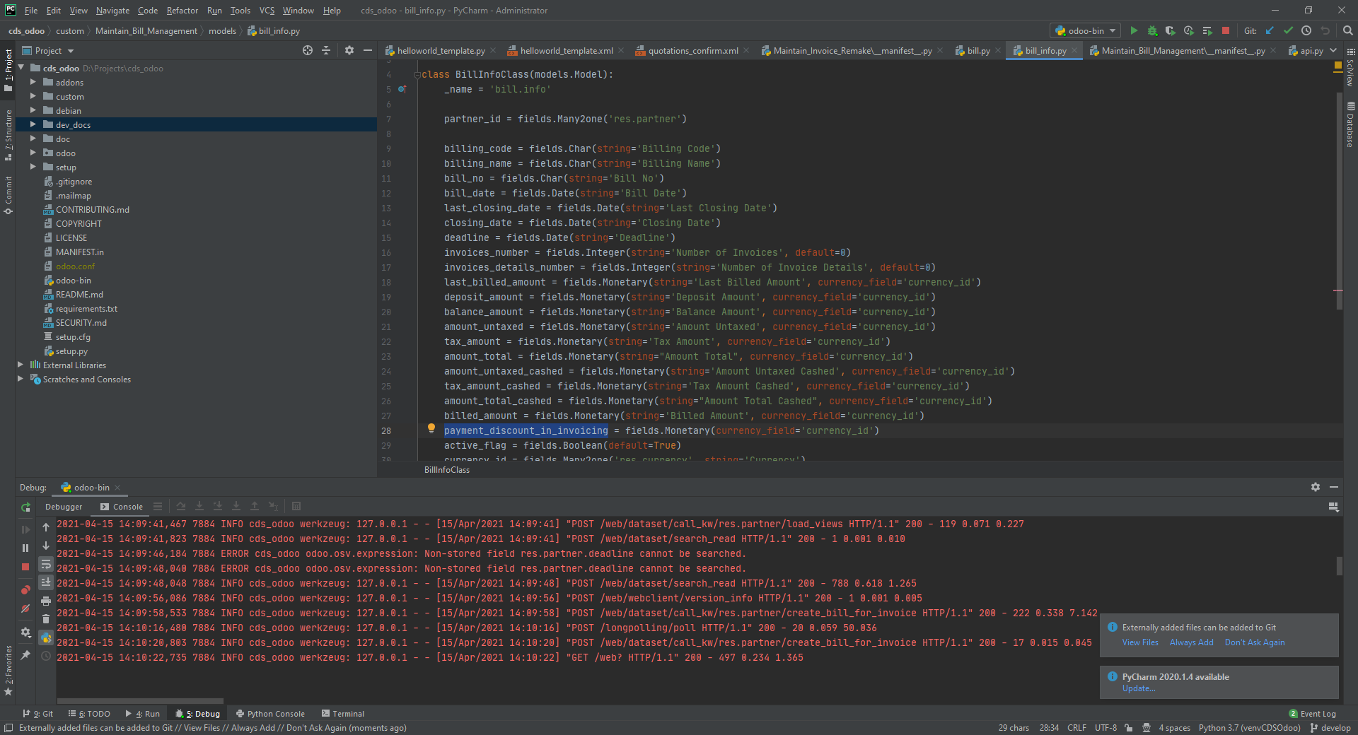

In this case, we need update the database with model in source code.

